PSHE (with RSE) Curriculum: Home Communication Pack

September 2024
What is PSHE (with RSE)?
From September 2021, the government introduced new statutory guidance on PSHE (with RSE): Relationships, Sex and Health Education. The guidance focuses on key areas:
Relationships:
- Families and People who Care for Me
- Caring Friendships
- Respectful Relationships
- Online Relationships
- Being Safe
Health:
- Mental Wellbeing
- Internet Safety and Harms
- Physical Health and Fitness
- Healthy Eating
- Drugs, Alcohol and Tobacco
- Health and Prevention
- Basic First Aid
- Changing Adolescent Body
This is statutory guidance, meaning that it is a legal requirement that all children access PSHE (with RSE) lessons and cannot be withdrawn.
In addition to this guidance, we have also incorporated the Government’s Citizenship program of learning:
- Developing confidence and responsibility and making the most of their abilities.
- Preparing to play an active role as citizens.
- Developing a health, safer lifestyle
- Developing good relationships and respecting the differences between people
- Breadth of opportunities
Official Government guidance from the Department of Education on PSHE (with RSE) and Citizenship can be found on our school website.

What is PSHE (with RSE)?
There are four main aims for teaching PSHE (with RSE) within the context of Primary schools:
- To enable young people to understand and respect their bodies and be able to cope with the changes puberty brings without fear or confusion.
- To help young people develop positive and healthy relationships appropriate to their age and development.
- To support young people to have positive self-esteem and body image, and to understand the influences, dangers and pressures that can affect them.
- To empower them to be safe and know how to ask for help when they are worried or uncomfortable.

Why is PSHE (with RSE) important for my child?
- Now more than ever before, children are exposed to ideas about relationships and sexuality through media/social media and the world around them. We need to equip children with the skills to make positive choices and recognise when the content they are exposed to is inappropriate.
- Research consistently shows that effective PSHE (with RSE) reduces the amount of risks children take later in life, and make wiser choices with regards to relationships.
- Because of the nature of the “online world” we now live in, children can easily be exposed to inappropriate content by people who mean them harm. By teaching children how to spot the signs of inappropriate harm. By teaching children how to spot the signs of inappropriate behaviour, both online and offline, we can help them to safeguard themselves and know how to seek support where needed.

What will my child learn in Sex Education?
We have planned an extensive scheme of work, inspired by materials from the PSHE Association, that will ensure all children receive a broad and balanced curriculum, addressing all areas of statutory guidance.
You will find a whole-school overview of our curriculum overleaf, followed by more detailed, termly overviews for each year group.
Over their time in school, children will learn about some elements of life related to their bodies, puberty and appropriate behaviour. Please note: at no point will a child be taught something that is inappropriate, and if a question arises and the teacher feels it would be inappropriate to answer, (for example because it is mature or explicit in nature), the child will be encouraged to ask their parents/carers at home.
The areas of focus for each year group are as follows:
- Nursery and Reception: How we have changed since we are babies.
- Year 1: The correct names for body parts and how different people’s bodies are the same and different, e.g. organs, hair colour and eye colour.
- Year 2: Knowing which parts of the body are private and how to ask for help if we feel unsafe.
- Year 3: Understanding the idea of consent, respecting others’ privacy and knowing which parts of the body are private and how to ask for help if we feel unsafe.
- Year 4: An introduction to puberty and how we should adapt our personal hygiene routines during this time.
- Year 5: How we should interact with strangers online and what safe and unsafe online conduct is.
- Year 6: A deeper look at puberty, including physical changes to the body and how to look after ourselves during this time. Understanding why consent is important and how to respect the privacy of others.

How is diversity addressed in the PSHE (with RSE) Curriculum?
DfE guidance requires all schools and academies to ensure that all pupils’ needs are met. This means that pupils must learn about the diverse society in which we now live today, and how to act in a respectful way to everybody they meet.
As a school, we are committed to equality, diversity and inclusion, and ensure our curriculum is reflective of the diversity in our school and local community. We regularly speak about all nine protected characteristics and the importance of being kind to everybody; children know that everyone should have access to equal rights, regardless of age, disability, gender, gender reassignment, marital status, pregnancy and maternity, race, religion or belief, sex and sexual orientation.
Whenever we explore themes related to LGBTQ+ people, this is delivered in a sensitive and age-appropriate way. LGBTQ+ relationships will be discussed in the context of other relationships, and will not be treated as separate or “different”. Pupils will not receive standalone lessons related to LGBTQ+ people within the PSHE (with RSE) Curriculum, however, much like when looking at other elements of diversity such as age, race or religious belief, this will be built into the curriculum where appropriate.
We never push any lifestyle upon our children. Rather, we encourage all of our children to love themselves and take pride in who they are as a person. We teach a message that everybody is deserving of respect, regardless of background, and equip our pupils with the skills to do this
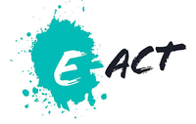
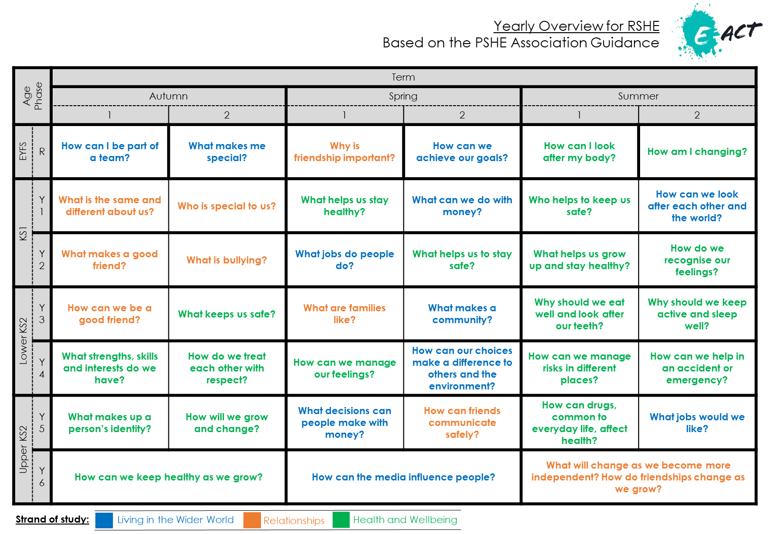
Yearly Overview for PSHE (with RSE)
Based on the PSHE Association Guidance
Strand of study:
Living in the Wider World
Relationships
Health and Wellbeing
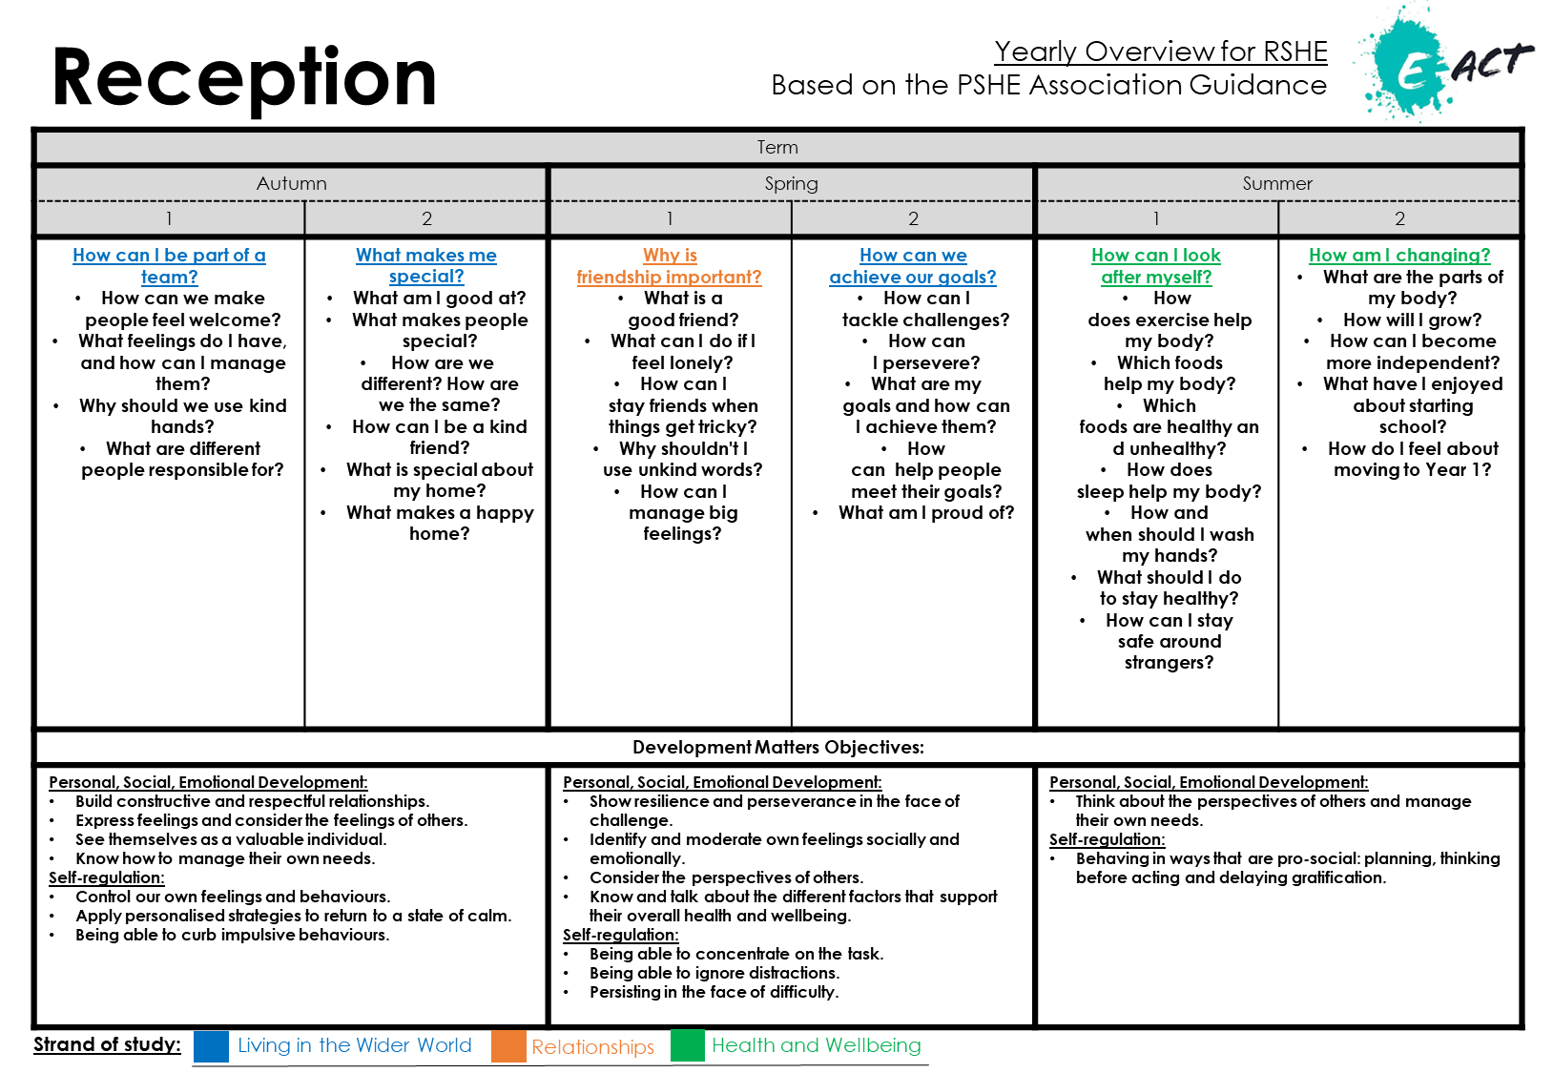
Yearly Overview for PSHE (with RSE)
Based on the PSHE Association Guidance
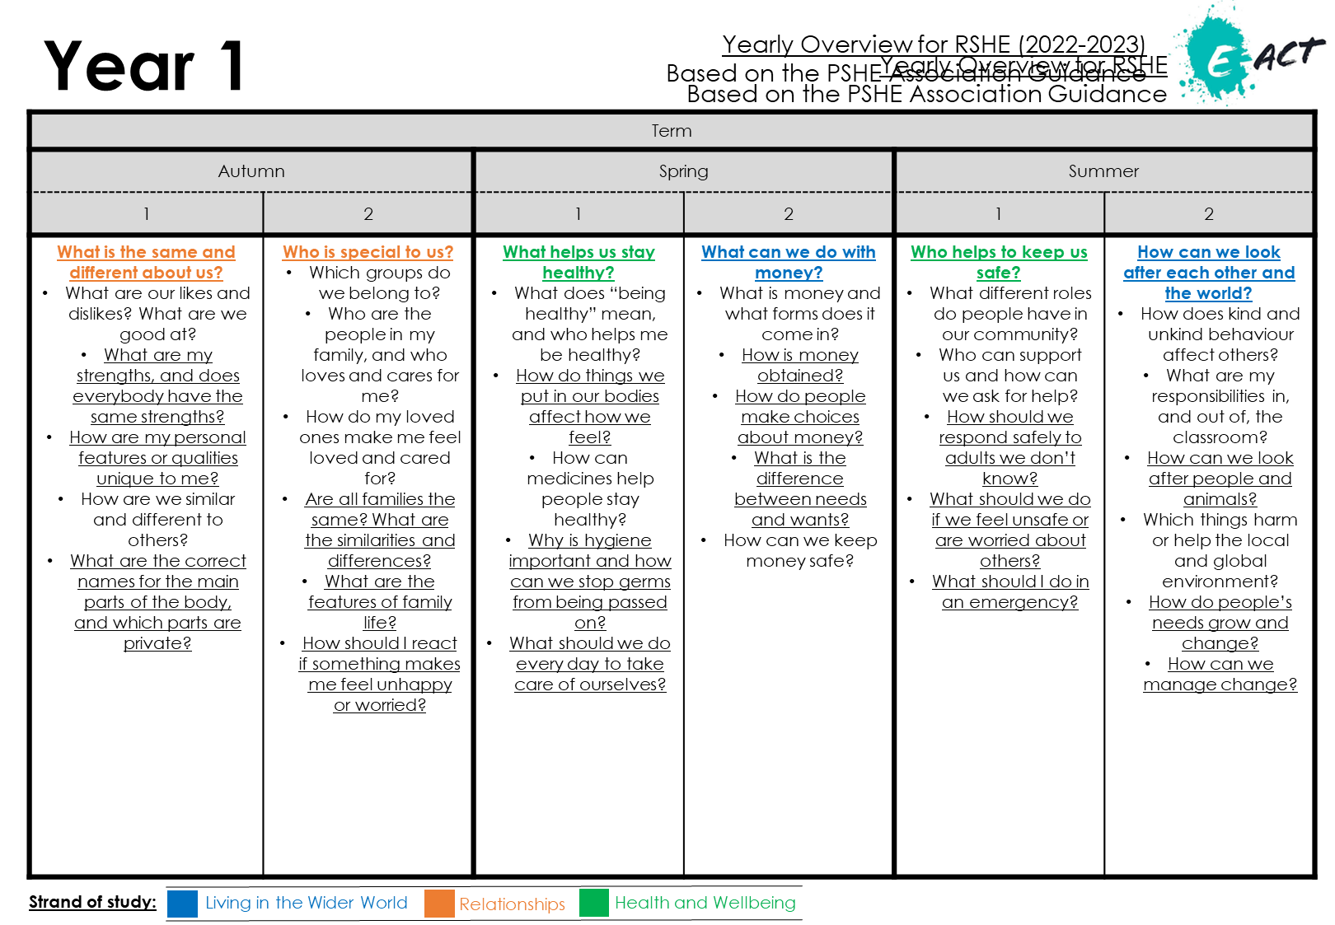
Yearly Overview for PSHE (with RSE)
Based on the PSHE Association Guidance
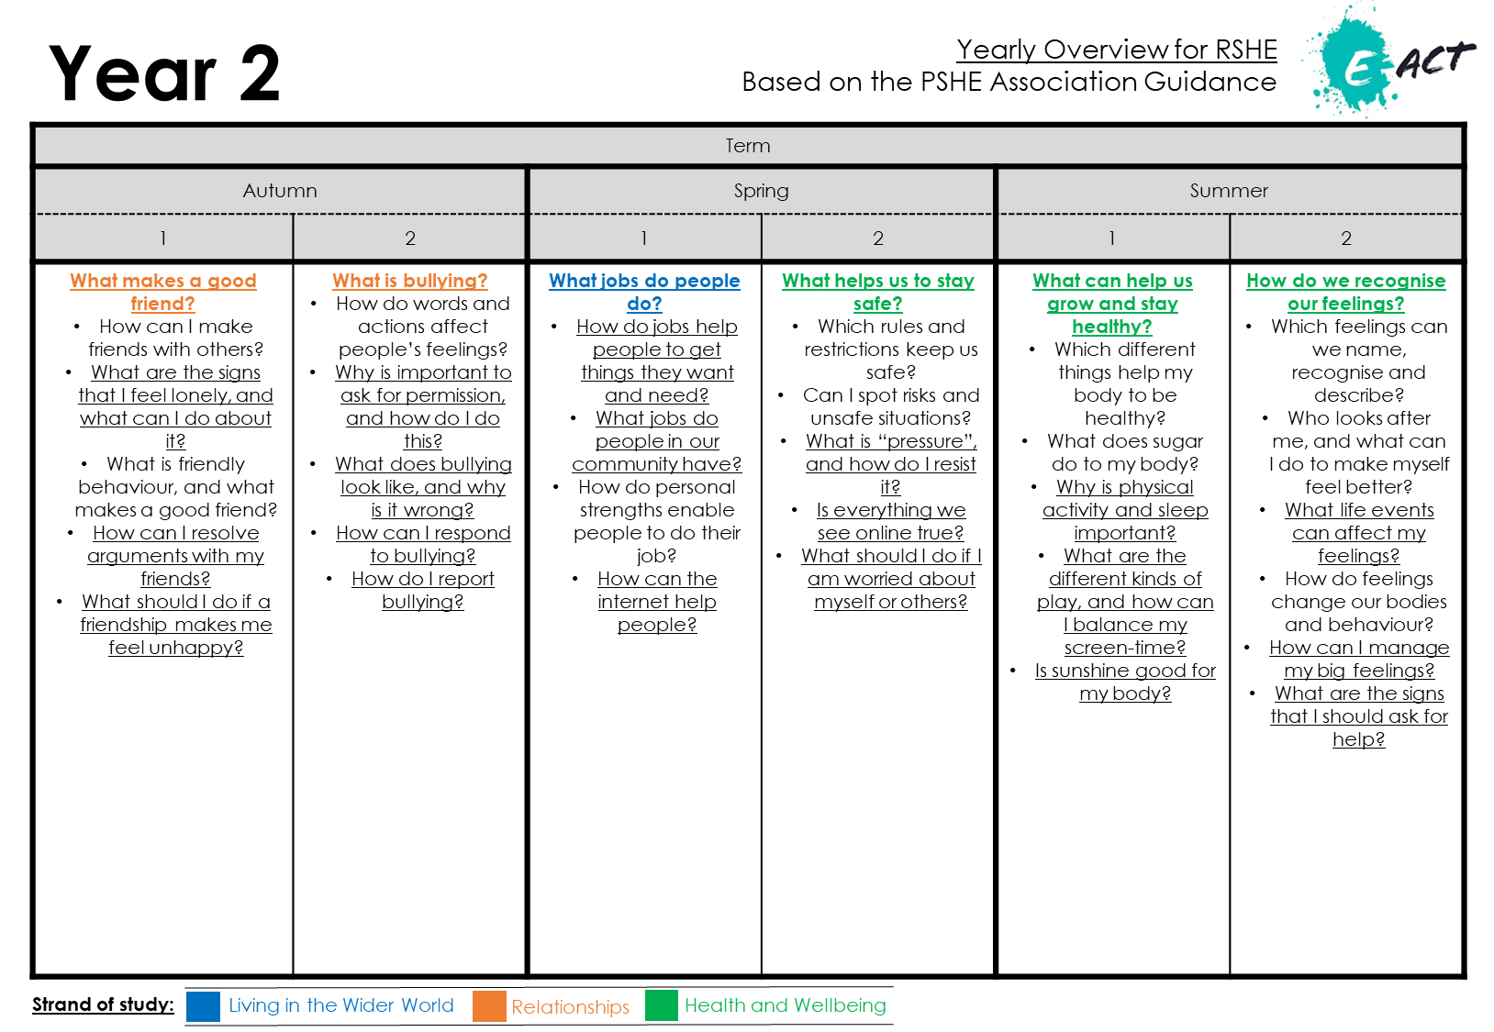
Yearly Overview for PSHE (with RSE)
Based on the PSHE Association Guidance
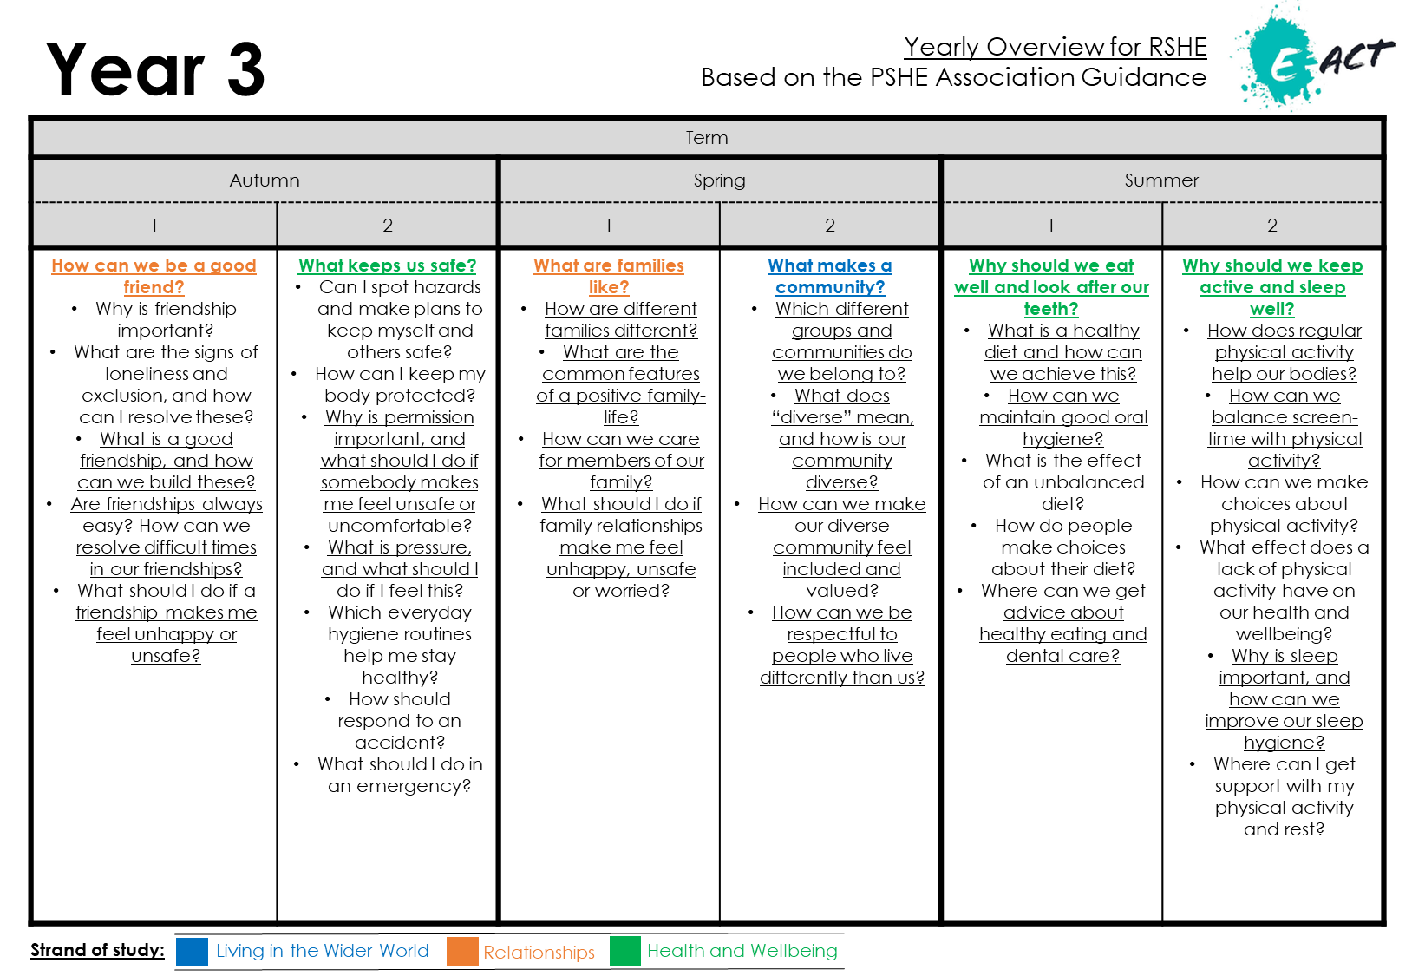
Yearly Overview for PSHE (with RSE)
Based on the PSHE Association Guidance
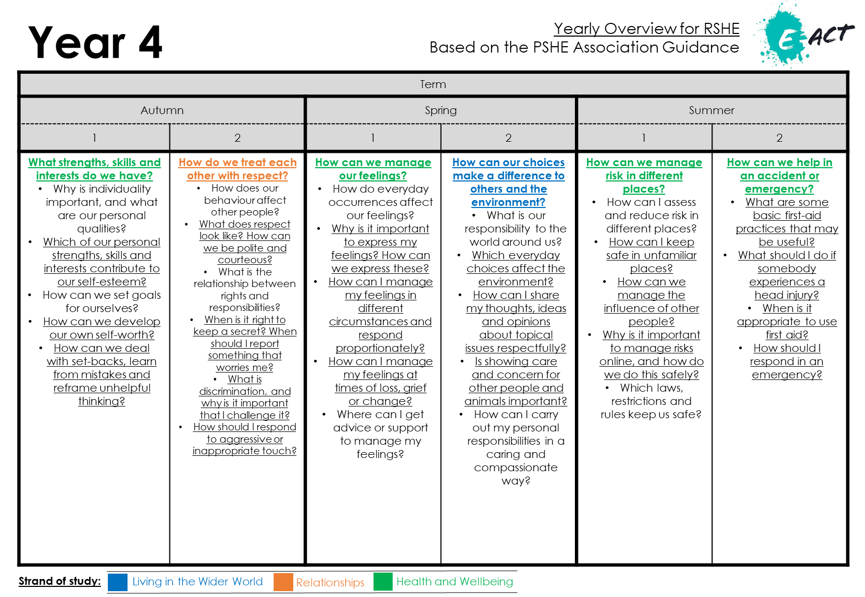
Yearly Overview for PSHE (with RSE)
Based on the PSHE Association Guidance
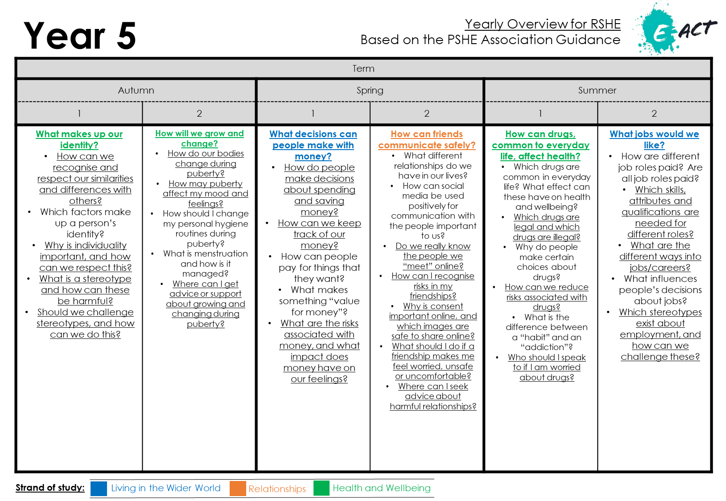
Yearly Overview for PSHE (with RSE)
Based on the PSHE Association Guidance
Yearly Overview for PSHE (with RSE)
Based on the PSHE Association Guidance
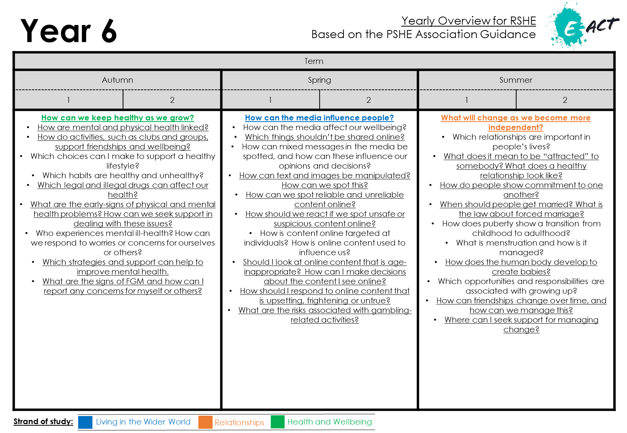
Yearly Overview for PSHE (with RSE)
Based on the PSHE Association Guidance

Can I withdraw my child from PSHE (with RSE)?
PSHE (with RSE) is a statutory, legal requirement for all children, reaching from the start of primary school until the end of secondary school. This means all children have a legal right to receive this element of the curriculum and can not be withdrawn from all sessions.
However, we also understand that there are some elements of the curriculum that you may be worried about. Where this is true, we are happy to accommodate and can arrange withdrawal from specific sessions. To do this, you should speak to your child’s class teacher and explain which elements of the curriculum you are worried about and discuss what alternative arrangements can be made.
When your child’s class teacher spots a lesson coming up on the curriculum that may involve difficult topics, they will aim to warn you beforehand; this will enable you to ask them questions and consider how you may want to address these issues at home if your child asks.
If you are considering limiting your child’s access to certain lessons, however, please consider the following:
- All lessons are planned to be completely age-appropriate. Although the idea of Sex Education may sound scary in the Primary context, children do not learn about sexual intercourse within PSHE (with RSE) lessons (Year 6 do cover this as part of the Science curriculum, but you will also be warned before this).
- Children talk… Sometimes, children find out about things that are age-inappropriate from one another and, as adults, we have no control of the information they are given. Without being taught the correct information by a reliable source, children can be given misleading, incorrect or confusing information by their peers. It may prove better to allow experienced and sensitive teaching staff to teach your child in a progressive, developmental way that is grounded in research.
- They will be learning about reproduction in animals and humans in Science lessons. The PSHE (with RSE) curriculum will echo this and will concentrate on teaching children how to enjoy healthy, appropriate relationships, improve self-esteem and self-confidence, and make healthy, informed choices.
- Children continue to study PSHE (with RSE) in high school. Some of the subjects studied in high school are more difficult and, without the building blocks provided in primary school, children may struggle to understand or cope with more challenging ideas.
We want our PSHE (with RSE) curriculum to be a partnership between our academy and the families of our pupils, with everyone working together for every child’s safety and benefit.

How should I talk to my child about relationships, puberty and the human body at home?
For some parents/carers, it can feel very natural to discuss relationships, puberty and the human body with their child, when they feel they are ready to learn this information. For others, it can feel awkward and difficult. Our mission is only ever to support these conversations and provide our pupils with the fundamental building blocks that they will need to keep them safe later in life:
- We all want children to feel and to be happy and healthy.
- We need to consider the needs of our children today and how we can protect them.
- We need to normalise talking about relationships, puberty and the human body so that children know it is okay to talk about in case they are ever worried about anything.

Here are some tips for talking to your child about these topics:
- Be honest: If you don’t know the answer to a question, be honest and say so. Tell your child that you will need to find out and that you will get back to them with more information soon.
- Remember that children are curious and want to know and understand: Sometimes children ask innocent questions as they are naturally curious. As adults, we can tend to panic and worry that these innocent questions could be about. If your child asks a question that you are worried about, try to be open to hearing why they have asked it, with questions such as, “What do you think that means?” or “Why do you ask?”
- Keep the lines of communication open: Having an open and honest communication with your child can really help make conversations easier, so make sure that you are always willing to talk when your child needs you; if you can’t, explain why and find another time when it is more mutually convenient. It is important your child knows that they can discuss these difficult topics with you, in the event that they need to tell you something that worried them.
- Use correct terminology: It helps that children aren’t confused by hints, euphemisms and innuendo; use the correct names and terminology whenever you can, especially for body parts. This is hugely important, as it means that, if ever they have a concern about this, they will know how to articulate it and be understood.
- Respond to what children say they need: Bear in mind that children’s lives today are very different from even five years ago. Therefore, the education they receive needs to reflect this. Research shows us time and time again that children want and need PSHE (with RSE) that is age-appropriate, that teaches them about relationships and emotions, and that prepares them for real-life problems they may face. We may worry about teaching them “too much”, but research shows that by addressing these areas with children, it prepares them to make wiser choices later in life and empowers them to safeguard themselves and others.
- Answer questions and don’t be afraid to admit what you don’t know! Have a phrase for awkward moments, such as, “That’s a good question. Let’s talk about it once we get home!”
- Always respond: If you don’t, your child may think it is wrong to talk about relationships, puberty or the human body. This means that, if they ever really need to, they are scared to talk about important issues in order to keep themselves safe. In addition, they may begin to research for themselves, limiting your control over what is age-appropriate.
- If it ever feels too personal: Try talking about people in books, films and favourite television programmes.
- Enjoy it: Don’t be scared to giggle about the awkward conversations with your child; feeling free to laugh and talk helps our children raise questions and concerns when they need to.
- Work in partnership: Speak to your child’s class teacher if you need support in how to deal with tricky subjects.

Further advice and support:
If you would like to review our PSHE (with RSE) curriculum, as well as statutory guidance, this can be found on our school website.
If you would like to see the materials being used to teach PSHE, please contact your child’s class teacher or our PSHE (with RSE) co-ordinator (Mr. Greenhow) by speaking to the school office, or emailing sean.greenhow@eba.e-act.org.uk directly.
If you have further questions, please contact your child’s class teacher; if you would still like to speak to somebody, please contact the schools’ PSHE (with RSE) co-ordinator (Mr. Greenhow) by speaking to the school office, or emailing sean.greenhow@eba.e-act.org.uk directly.
We are very excited to introduce this new curriculum and feel it will greatly benefit all of our pupils. Thank you for taking the time to review all of our hard work and for your cooperation.

