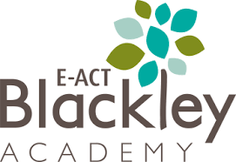
Nursery – Topic Overview Map
In Summer 2, our Nursery pupils will be learning…
Additional
Celebrations – Father’s Day
Sports Day

Expressive Arts and
Design
Exploring materials for use in different ways.

Changing sounds.

Physical Development
PE Focus – Spatial Awareness
To use space safely and recognise directions and travel with control in a variety of ways.

Use a pencil to form some letters correctly.

Understanding the World
Show interest in different occupations and ways of life.
Explore who we have met and the people in the community.

Personal, Social and Emotional Development
To set personal goals.
To challenge themselves.

Communication and Language
Retell a familiar story.
To develop their vocabulary through role play.
Use new vocabulary in different contexts.

Mathematics
To arrange concrete objects in different ways, exploring splitting quantities and sharing objects.
Practise solving simple problems in a variety of contexts.

Literacy
Focusing on non-fiction texts to support the topic of ‘people who help us’.
Exploring the text “The Jolly Postman”.
Phonics- Phase 2 Little Wandle.

