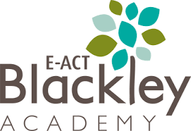
Nursery – Topic Overview Map
In Summer 1, our Nursery pupils will be learning…
Additional
Celebrations – Eid, Coronation of King Charles.
Cultural celebration event.

Expressive Arts and
Design
Changing colours – Exploring mixing the three primary colours to create secondary colours.

Physical Development
Develop use of equipment, demonstrating increasing skill and purpose.
Further developing fine motor skills.
PE focus- Can I control a ball?
Understanding the World
Exploring places- Settings in stories, familiar places around us.
Exploring materials – Three Little Pigs home building.

Personal, Social and Emotional Development
PSED is taught and developed across curriculum areas.
Focus on turn taking.

Communication and Language
Listen to and talk about stories to build familiarity and understanding.
Engage in non-fiction books.

Mathematics
Use knowledge of numbers to solve simple problems.
Comparing groups of objects.
Represent numbers in a variety of ways.
Exploring shapes.
Literacy
Focusing on traditional tales such as Little Red Riding Hood and Goldilocks and the Three Bears.
Describes main story settings.
Talk about the story structure
Phonics- Phase 2 Little Wandle.

