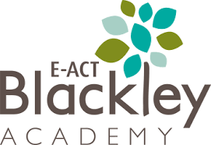
Nursery – Topic Overview Map
In Spring 2, our Nursery pupils will be learning…
Communication and Language
To describe events in some detail
Use talk to help work out problems and organise thinking.
Connect ideas and actions to another with a range of connectives.

Physical Development
Develop pencil grasp (modified/tripod grasp) and demonstrate control, such as by colouring in, writing letters in their name,
PE – Dance Focus
“Can I move like an animal?”

PE – Dance Focus
“Can I move like an animal?”

Understanding the World
Plant seeds and care for growing plants.
Understand the key features of the life cycle of a plant and an animal.
Begin to understand the need to respect and care for the natural environment and all living things.
Science Link: Plants
How do we know it’s growing?

Expressive Arts and
Design
DT Link
“Can I use materials to represent my world?”
Music Link
“Can I make sounds with my body?”

Additional
Celebrations – Mother’s Day
- Easter

Personal, Social and Emotional Development
Play with one or more other children, extending and elaborating play ideas. Find solutions to conflicts and rivalries.
Increasingly follow rules, understanding why they are important.

Mathematics
Confidently recite number names in sequence to 10 and beyond.
Consistently apply the counting principles to 10.
Represent numbers in a variety of ways, including choosing corresponding numerals.
Literacy
Exploring the text, “The Very Hungry Caterpillar”
Exploring non fiction texts focusing on minibeasts.

