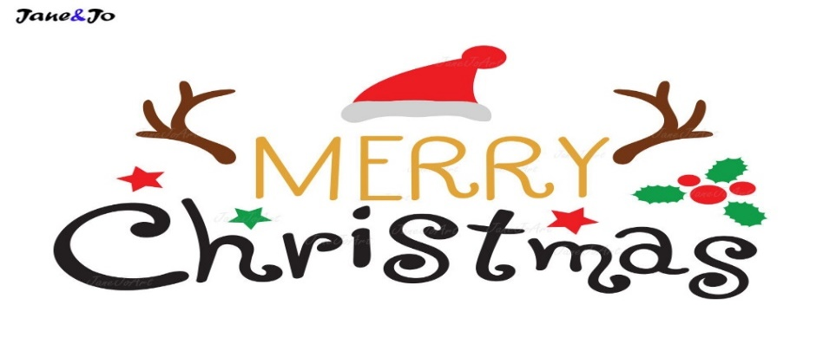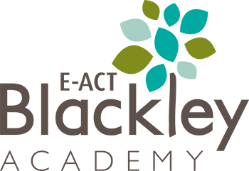

**December dates to remember**

**Friday 1st December** – Reindeer Run

**Wednesday 6th December** – Breakfast with Santa (under 3’s)

***Thursday 7th December***  - Christmas Jumper Day

***Thursday 7th & Friday 8th December*** – Rookie Rockstars Performances for parents – ***Tickets only. These are available to purchase now on Parentpay.***

***Monday 11th December***- KS1 (Y1 & Y2) Christmas performance 9.30am

***Tuesday 12th December*** – EYFS (Nursery & Reception) Christmas performance 9.30am

***Wednesday 13th December*** – Y3 & Y4 Christmas performance 9.30am

***Wednesday 13th December*** – Y5 & Y6 Christmas performance 2.30pm

***Thursday 14th December*** – Christmas Lunch

***Friday 15th December*** – School finishes for Christmas

**Christmas Lunch**

**Thursday 14th December**

**Main** – Roast Turkey with sticky chipolata

(V) – Roasted vegetable & cranberry puff pastry wreath

**Sides** – Roasties, Christmas vegetable medley & gravy

**Dessert** – Christmas pudding rice krispie ball or white chocolate snowball cookie



**Half Term**

**Friday 15th December 2023 – Wednesday 3rd January 2024**

**HAPPY HOLIDAYS**



**School Holidays 2023/ 2024**

**Christmas holiday**

School closes: Friday 15 December 2023

**INSET DAY:** Tuesday 2 January 2024

School opens: Wednesday 3 January 2024

**Half term holiday**

School closes: Friday 16 February 2024

**INSET DAY:** Monday 26 February 2024

School opens: Tuesday 27 February 2024

**Easter holiday**

School closes: Thursday 28 March 2024

School opens: Monday 15 April 2024

**Bank holiday**: School closes Monday 6 May 2024

**Half term holiday**

School closes: Friday 24 May 2024

School opens: Monday 3 June 2024

**Summer holiday**

School closes: Wednesday 24 July 2024

E-ACT Blackley Academy

December 2023

Points of Contact

|  |  |  |
| --- | --- | --- |
| **Example Context** | **Who to contact** | **Recommended method of contact** |
| General Information: Homework, uniform list, curriculum, school events, holiday dates etc… | Website | Website |
| General issues relating to class, Learning, uniform, welfare etc… | Class Teacher | Class Dojo |
| More serious Issues relating to bullying, learning, welfare etc… | Class Teacher  Phase Leader | Meeting  Appointment via class dojo |
| Concerns that have not been able to be resolved via class teacher or phase leader.  Concerns about the school more generally.  Concerns about a member of staff. | James Hughes (Head Teacher) | Appointment via email  [James.hughes@eba.e-act.org.uk](mailto:James.hughes@eba.e-act.org.uk)  0161 740 2185 |
| SEND: If you have questions regarding special educational needs. | Class teacher  Gemma Spence (SENCO) | Appointment via Class Dojo  or  [Gemma.spence@eba.e-act.org.uk](mailto:Gemma.spence@eba.e-act.org.uk) |
| Attendance: If you need to report your child absent. | Matthew Nuttall | Contact via phone  0161 740 2185 |
| Complaints | Please follow our complaints policy | <https://blackleyacademy.e-act.org.uk/wp-content/uploads/sites/6/2022/11/E-ACT-Complaints-Policy-and-Procedure-2022.pdf> |
| Family Support: Early Help, financial support, free school meals, mental health etc… | Tunde King  Rhonda Alleyne | [Tunde.king@eba.e-act.org.uk](mailto:Tunde.king@eba.e-act.org.uk)  [Rhonda.alleyne@eba.e-act.org.uk](mailto:Rhonda.alleyne@eba.e-act.org.uk) |
| Safeguarding: If you are concerned about the safety of a child. | Gemma Spence | [Gemma.spence@eba.e-act.org.uk](mailto:Gemma.spence@eba.e-act.org.uk) |
| SEND: If you have a query regarding special educational needs. | Gemma Spence | [Gemma.spence@eba.e-act.org.uk](mailto:Gemma.spence@eba.e-act.org.uk) |
| General Support – Dropping off medicine, ParentPay, Changes of details, Changes of meals. | School Office | [Blackley.Office@E-ACT.org.uk](mailto:Blackley.Office@E-ACT.org.uk)  [Blackley.Parents@E-ACT.org.uk](mailto:Blackley.Parents@E-ACT.org.uk) |

Useful Information

* Drop off and pick up times  
  School gates open at 8.35am and close at 8.50am each morning. Gates re-open at 3.15pm for end of day collections. Please ensure children are dropped off and collected on time.  
  Breakfast club  
  Breakfast club is available from 7.45am Monday -Friday as a cost of £1 per day. You do not need to sign up for this in advance, arrive at the hall and a member of the breakfast club team will sign the child in. A payment request will be forwarded to Parentpay.
* Medicine  
  Medicine can be dropped off at the school office at the start of the day. We can accept and administer medication under the following conditions;  
  - Medicine has to be taken 4 times a day;  
  - Medicine has been prescribed by a doctor, and is in its original packaging;  
  - You have completed a medication form (available from the school office).
* School Meals   
  Schools meals are charged at £2.26 per day, unless the child is entitled to free school meals. Payment for meals to be made via Parentpay. Failure to make regular payments will result in you being asked to provide your child with a packed lunch. Any changes to school meals must be made in writing/email to the school office. If you think you may be entitled to free school meals please make an online application via [www.cloudforedu.org.uk/ofsm/sims](http://www.cloudforedu.org.uk/ofsm/sims).