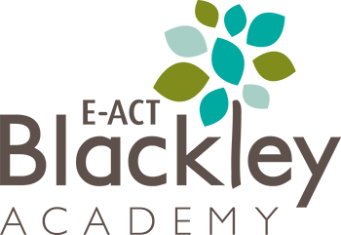
Dear parent or carer,
I hope my message finds you safe and well.
Following on from tonight’s government announcement, I am writing to confirm that our academy, alongside all other schools and academies in England, will only be open to our most vulnerable pupils and the children of critical workers from Wednesday 6th January 2021 (This one day delay is due to our Heating situation that was communicated today). We must ask all other children to stay at home and complete their learning using our online platforms.
The remainder of this letter will outline the main things that parents and carers need to be aware of over the coming weeks.
Who should attend the academy on Wednesday 6th January 2021?
The academy will be open to our most vulnerable pupils and the children of critical workers, who have no other adult at home, across all year groups. You can check whether your child is part of either of these groups by clicking here.
All other children are asked to stay at home and complete their learning using our online platforms. If you have any questions, please contact us on 0161 740 2185 or sarah.white@eba.e-act.org.uk.
When will my child be able to return to the academy?
The Prime Minister in his announcement mentioned that schools and academies could be asked to operate in this way until at least the February half term.
We plan to keep in close contact with you and will be in touch as soon as we have the greenlight to welcome back more of our pupils.
Remote education arrangements for our children
We have plans in place which mean that the pupils who must stay at home can continue their learning without disruption. Children will have daily contact with their teachers and will continue to be taught a wide range of subjects in line with their academy timetables where possible. Teachers will provide daily lessons that have been recorded and posted on Class Dojo.
We will be taking a daily register and our teachers will closely monitor progression, adjusting pace or difficulty of work where necessary.
Please visit our website, www.blackleyacademy.e-act.org.uk, for more information.
For children entitled to free school meals
Details of the arrangements for pupils who are eligible for free school meals and are being taught remotely will be provided on Wednesday 6th January.
Ensuring the safety of our pupils in academy
Please rest assured that the pupils attending academy will continue to have access to the safest possible academy environment. Our COVID safety measures, which include regular and focussed cleaning, good ventilation and ensuring good hand and respiratory hygiene will be reinforced at all times.

Who should I inform if my child tests positive for the virus?
If your child or someone else within your household tests positive for COVID-19, please let the academy know by emailing the details to Matthew.Nuttall@eba.e-act.org.uk or by calling 0161 740 2185.
Thank you for your support
These are unprecedented times, but I would like to reassure you that all our pupils and families will continue to receive support from the academy no matter the circumstances.
We plan to remain in regular contact with you, and we ask you to do the same if you have any questions or concerns. In the meantime, I wish you and your family well, and I take this opportunity to thank you for your continued support of the academy.
Yours sincerely,
James Hughes
Headteacher – E-ACT Blackley Academy

