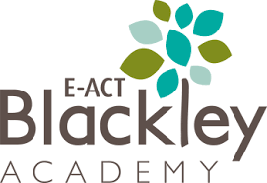

E-ACT Blackley Distance Learning – A guide for a parents and carers

Our vision for teaching and learning at E-ACT BLackely Academy, reflects the high expectations and aspirations that all staff have of themselves and their learners.
In these unprecedented times, how we educate and support the students in our care has had to alter, as of the 20th of April we will be making some changes to how we deliver online learning content to the students of E-ACT Blackely.
We would like to thank all members of our staff for their hard work-under exceptional circumstances in striving to continue the learning opportunities for our students. We would also like to thank all parents and carers for working with us to provide support, encouragement and guidance at home, we understand that this role has not, and will not always be easy. Finally, thank you to our students for engaging with their education in a different way; everything that we are doing is to support you and we know how much you value this.
Now more than ever, we encourage our students to take responsibility for their own learning, teaching them to be resilient in overcoming set-backs and persist with achieving their goals. This handbook seeks to provide guidance of what we envisage education to look like over the coming weeks.

As of the 20th April 2020 all class teachers will set work on Class Dojo. Work will be set as a ‘task’ for the children to complete.
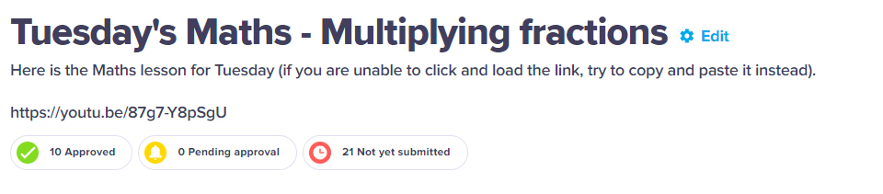
Sessions will mostly be filmed over PowerPoints, this enables the children to ‘see’ their teacher and engage in a meaningful lesson, albeit it from their own home. In order for children to complete their tasks they will need to click on the Youtube links that will be displayed on their class story feed.

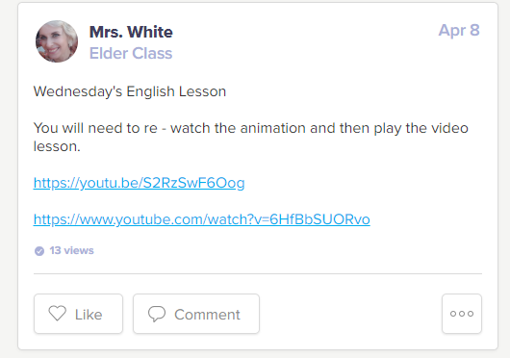

Teachers will deliver sessions, much like they would do in their classroom; asking the children to pause the video so that they can answer questions, before moving on to the next section of the video. It is recommended that children have a pen and paper to hand before starting their lessons, additional guidance will also be given in the lesson task overview. Teachers may still refer children to Education City or SATS Companion, however this will be as an additional task to the taught-virtual lesson.
Both children and parents can have access to the portfolio/class story- if you haven’t activated your parent login please contact your child’s class teacher and they can send it over to you via email. There is also a link for how to do this on our website.

Daily Expectations
There will be 5 activities set each day
- English-this could be a reading or writing task and will also include a grammar, punctuation or spelling activity.
- Maths – this will include fluency, reasoning and problem-solving aspects of mathematics (teachers may also signpost children to challenges set on Times Tables Rockstars)
- 1 Foundation Subject per day (Science, History, Geography, RE, Art etc)
- 2 ‘other activities’ – these will be links to activities from other providers such as Joe Wick’s PE sessions, Oti’s dance class, mindfulness activities. One of the links will be a class story, either filmed by the teacher or a link to an author reading their book.

Sample timetable

Year 6 Elder & Sycamore  W.B 6.04.2020 | Monday | Tuesday | Wednesday | Thursday | Friday
AM | YOUTUBE VIDEO -CD  Maths  Multiplying fractions | YOUTUBE VIDEO -CD  Maths  Multiplying fractions | YOUTUBE VIDEO – CD  Maths  Dividing Fractions | YOUTUBE VIDEO – CD  Maths  Fractions of an amount | YOUTUBE VIDEO – CD  Maths  Fractions- revision session
 | BREAK | BREAK | BREAK | BREAK | BREAK
AM | YOUTUBE VIDEO- CD  Lesson 4  English  The Lighthouse- final draft | YOUTUBE VIDEO- CD  Lesson 5  English  The Lighthouse- final draft | YOUTUBE VIDEO – CD  English  The Performance – L1  GPS: Relative Clause | YOUTUBE VIDEO – CD  English  The Performance – L2  GPS: Expanded nun sentences | YOUTUBE VIDEO – CD  English  The Performance – L1  GPS: Word choices
 | LUNCH | LUNCH | LUNCH | LUNCH | LUNCH
PM | YOUTUBE VIDEO – CD  PSHE– Jigsaw L2 | YOUTUBE VIDEO – CD  Geography – Lesson 2 Rivers | YOUTUBE VIDEO – RE  The Easter Story  & Google Form Questionnaire. | YOUTUBE VIDEO – CD  Science Lesson 2- Classification - Creating a classification key | Art - Video tutorial from YT- Continuous Line drawing
Anytime throughout the day | Daily- Story Session form BBC- Michael Morpurgo, War Horse  Mon, Weds, Fri – PE link with Joe Wicks  Tues, Thurs – Mr Mckernan’s Learning

Feedback
Teachers will approve all work completed to an acceptable standard. This will then appear in the child’s portfolio, where it can be viewed by both parents and students. Whilst teachers will not ‘virtual mark’ every piece that is submitted, a selection of work will be responded to each day, teachers will often give children a response in relation to a ‘next step’ which students can then respond to.

Celebrating Success
On a Friday we would normally hold a VIP award in our assembly. This will continue. Each week the class teacher will award a VIP certificate to a student who has gone ‘above and beyond’ that week. These certificates will be posted on the class story feed every Friday morning.
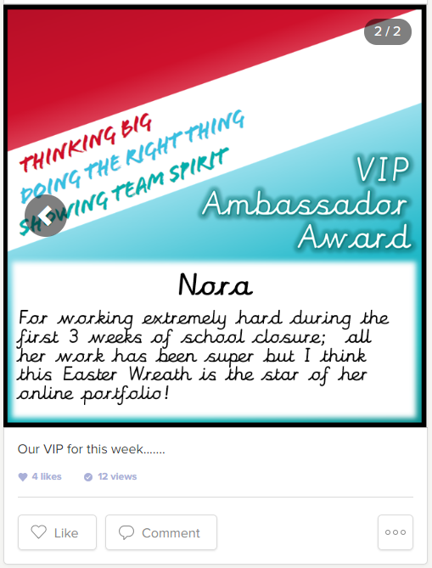

Basic Expectations
The Academy will ensure that:
Teaching staff set regular tasks that help the children to reconsolidate existing learning.
Teaching staff will be available to answer any work-related questions via Class Dojo or their work e-mail address – these can be found on the website
Every student and family will be called fortnightly to check on their wellbeing (physical and emotional), as well as to offer/signpost any available support.
Exercises to encourage good physical wellbeing will be included within the weekly timetable.
Resources to encourage good emotional wellbeing will be included within the weekly timetable.
Staff will award VIP certificates to celebrate success.
Students will ensure that:
Any academic work set for them will be completed to the best of their ability.
They or their parent/carer will contact individual members of teaching staff for support with their academic work if and when necessary.
They or their parent/carer will contact their teacher if they have any concerns with their physical or emotional wellbeing.

Parents/carers will ensure that:
They encourage their child to complete the academic work set for them to the best of their ability.
They either contact individual teachers themselves or encourage their child to do so, if any support is required to complete/understand the academic work set.
They either contact individual teachers themselves or encourage their child to do so, if they have any concerns with their child’s physical or emotional wellbeing, as well as their own.
Any communication with staff is polite, courteous and professional at all times.

Accessing virtual lessons on YouTube
From Monday 20th April 2020, we will be sending children virtual lessons, via videos posted to YouTube.
Before engaging with these lessons, we would advise all families watch the following advice on how to stay safe on YouTube:
https://youtu.be/sK2GAGR5X4Q
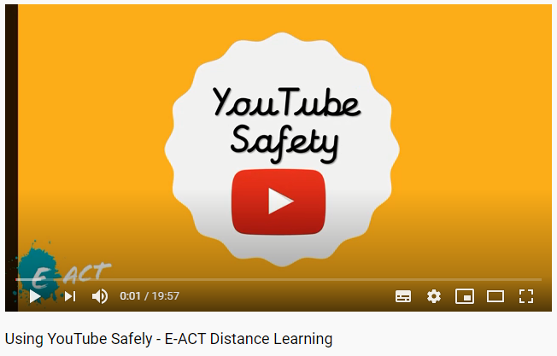

Class teachers will post links to these videos via Class Dojo, but if you would like to easily find the channel of your child’s teacher, please use the links below:
Teacher |  | Year Group | Distance Learning Channel
 | Miss Szulek |  | https://www.youtube.com/channel/UCtvaZz-CpjEqOQCeq0vS_yA/playlists
 | Miss Weaver | Nursery | https://www.youtube.com/channel/UCiuZ32UUEcmIMNy4yxpS-NQ/playlists?view_as=subscriber
 | Miss Dunnington | Reception | https://www.youtube.com/channel/UCHKCRxFpmsBhFAhlC5XNXBQ/
 | Miss Lilley | Reception | https://www.youtube.com/channel/UCKEdbEenNG-YsgSjywxoITQ?view_as=subscriber
 | Miss Adams | Year 1 | https://www.youtube.com/channel/UCztjVFaT6mhEO8-MhfYiQgA/featured?disable_polymer=1
 | Miss Spencer | Year 2 | https://www.youtube.com/channel/UCLzzrtzRUbRMdlAxL0_jVrg
 | Miss Bewley | Year 2 | https://www.youtube.com/channel/UCIK2X1npVtg8WWykq7E5h9Q?view_as=subscriber
 | Miss Watmough | Year 3 | https://www.youtube.com/channel/UCHG3txdGKBpxLOUMPjLYjwQ/?guided_help_flow=5
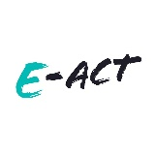 | Mr Ingram | Year 3 | https://www.youtube.com/channel/UC4Kk567wSZqlcpevF8upxvw/featured
 | Mr Stewart | Year 4 | https://www.youtube.com/channel/UCOu_poL3-yb6gdT8VS-qdng/playlists?view_as=public
 | Mrs Fitzpatrick | Year 4 | https://www.youtube.com/channel/UC9rOA2qwJch_q32sleQ004w/playlists
 | Mr Greenhow | Year 5 | www.tinyurl.com/year5youtube
 | Mrs Mitchell | Year 5 | https://www.youtube.com/channel/UCC3xdMM8AEsU8j2MTZNwJTQ/playlists?disable_polymer=1
 | Mrs White | Year 6 | https://www.youtube.com/channel/UCNj7HAPCpbGya3wSvY3EYHg?view_as=subscriber
 | Mrs Heshri | Year 6 | https://www.youtube.com/channel/UCIkCVr96CfmxdUWN1UQZmeg
 | Mrs Hilton | Year 6 | https://www.youtube.com/channel/UCHGPYyNy2IEmvEbzd3-NgkQ/videos
 | Miss Spence | Hazel Hub/  Willows | https://www.youtube.com/channel/UCIyQc-jx9nYYTxFAgnzww4g/

